## **Cluster Autoscaler on AWS EKS**

The Kubernetes Cluster Autoscaler automatically adjusts the number of nodes in your cluster when pods fail or are rescheduled onto other nodes. On AWS, Cluster Autoscaler utilizes Amazon EC2 Auto Scaling Groups to manage node groups. Cluster Autoscaler typically runs as a Deployment in your cluster.

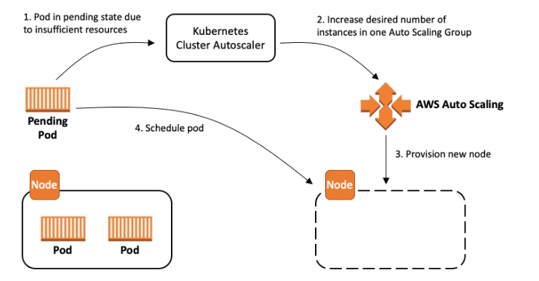

*Source-* [*https://aws.github.io/aws-eks-best-practices/cluster-autoscaling/*](https://aws.github.io/aws-eks-best-practices/cluster-autoscaling/)

## **Creating an IAM OIDC provider for your cluster**

Determine whether you have an existing IAM OIDC provider for your cluster. Retrieve your cluster's OIDC provider ID and store it in a variable. Replace my-cluster with your own value.

**To create an IAM OIDC identity provider for your cluster with eksctl**

1. Determine whether you have an existing IAM OIDC provider for your cluster. Retrieve your cluster's OIDC provider ID and store it in a variable. Replace my-cluster with your own value.

**export cluster_name=my-cluster**

**oidc_id=$(aws eks describe-cluster --name $cluster_name --query "cluster.identity.oidc.issuer" -- output text | cut -d '/' -f 5)**

1. Determine whether an IAM OIDC provider with your cluster's ID is already in your account.

**aws iam list-open-id-connect-providers | grep $oidc_id | cut -d "/" -f4**

If output is returned, then you already have an IAM OIDC provider for your cluster and you can skip the next step. If no output is returned, then you must create an IAM OIDC provider for your cluster.

1. Create an IAM OIDC identity provider for your cluster with the following command.

**eksctl utils associate-iam-oidc-provider --cluster $cluster_name --approve**

## **Create IAM Policy**

Creating an IAM policy for your service account that will allow your CA pod to interact with the autoscaling groups.

**vi ca-iam-policy.json**

{

"Version": "2012-10-17",

"Statement": [

{

"Action": [

"autoscaling:DescribeAutoScalingGroups",

"autoscaling:DescribeAutoScalingInstances",

"autoscaling:DescribeLaunchConfigurations",

"autoscaling:DescribeTags",

"autoscaling:SetDesiredCapacity",

"autoscaling:TerminateInstanceInAutoScalingGroup",

"ec2:DescribeLaunchTemplateVersions"

],

"Resource": "*",

"Effect": "Allow"

}

]

}

**aws iam create-policy \**

**--policy-name k8s-cluster-autoscaler-asg-policy \**

**--policy-document** **file://ca-iam-policy.**json

## **Create IAM Role**

Create an IAM role for the cluster-autoscaler Service Account in the kube-system namespace.

**export AWS_ACCOUNT_ID="<Enter your AWS Account ID>"**

**eksctl create iamserviceaccount \**

**--name cluster-autoscaler \**

**--namespace kube-system \**

**--cluster <your-cluster-name> \**

**--attach-policy-arn "arn:aws:iam::${AWS_ACCOUNT_ID}:policy/k8s-cluster-autoscaler-asg-policy" \**

**--approve \**

**--override-existing-serviceaccounts**

**Edit node group:**

* **Select Your Cluster**: In the Amazon EKS console, select the EKS cluster that contains the node group you want to edit.
* **Navigate to Node Groups**: In the left sidebar, click on "Node groups" under the "Compute" section.
* **Select the Node Group**: Click on the node group that you want to edit. This will take you to the details page for that node group.
* **Click "Edit Configuration"**: On the node group details page, click the "Edit configuration" button. This will allow you to modify the configuration of the selected node group.
* **Make Desired Changes**: You can now make the desired changes to the configuration of the node group. This might include adjusting the desired capacity, min/max size, instance types, and other settings.
* **Review and Apply Changes**: After making the necessary changes, review your edits to ensure they are correct. Once you're satisfied, click the "Apply" button to save and apply your changes.

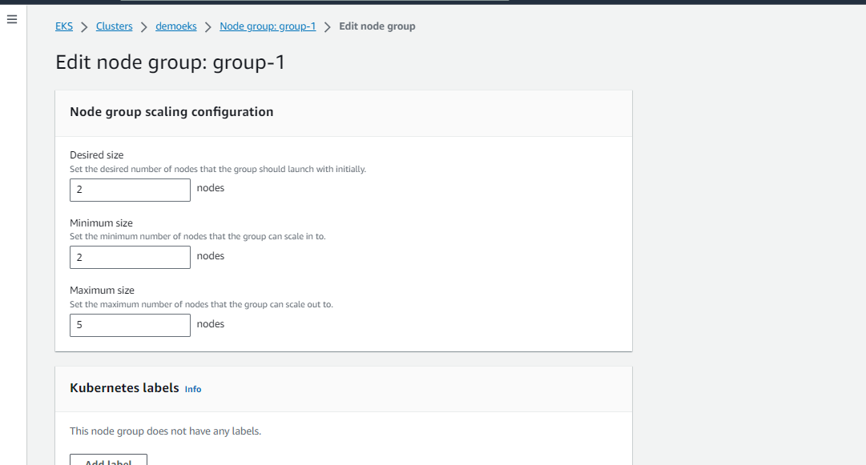

Edit Based on requirement.

## **Deploy Cluster Autoscaler**

1. Download the **cluster-autoscaler-autodiscover.yaml**

**curl -O** [**https://raw.githubusercontent.com/kubernetes/autoscaler/master/cluster-autoscaler/cloudprovider/aws/examples/cluster-autoscaler-autodiscover.yaml**](https://raw.githubusercontent.com/kubernetes/autoscaler/master/cluster-autoscaler/cloudprovider/aws/examples/cluster-autoscaler-autodiscover.yaml)

1. **Edit the cluster-autoscaler-autodiscover.yaml yaml file**

**spec:**  
 **containers:**  
 **- command:**  
**- ./cluster-autoscaler**  
 **- --v=4**  
 **- --stderrthreshold=info**  
 **- --cloud-provider=aws**  
 **- --skip-nodes-with-local-storage=false**  
 **- --expander=least-waste**  
 **- --node-group-auto-discovery=asg:tag=k8s.io/cluster-autoscaler/****enabled,k8s.io/cluster-autoscaler/<YOUR CLUSTER NAME>**

**3.** Deploy the yaml file

**kubectl apply -f cluster-autoscaler-autodiscover.yaml**

4. Edit the Cluster Autoscaler deployment with the following command.

**kubectl -n kube-system edit deployment.apps/cluster-autoscaler**

Edit the cluster-autoscaler container command and add the following options.

* **--balance-similar-node-groups**
* **--skip-nodes-with-system-pods=false**

Save and close the file to apply the changes.

**spec:**  
 **containers:**  
 **- command:**  
 **- ./cluster-autoscaler**  
 **- --v=4**  
 **- --stderrthreshold=info**  
 **- --cloud-provider=aws**  
 **- --skip-nodes-with-local-storage=false**  
 **- --expander=least-waste**  
 **- --node-group-auto-discovery=asg:tag=k8s.io/cluster-autoscaler/enabled,k8s.io/cluster-autoscaler/<YOUR CLUSTER NAME>**  
 **- --balance-similar-node-groups**  
 **- --skip-nodes-with-system-pods=false**

5. Set the Cluster Autoscaler image tag to the version that you recorded in the previous step with the following command. Replace *1.27.n* with your own value.

**kubectl set image deployment cluster-autoscaler \**

**-n kube-****system \**

**cluster-autoscaler=k8s.gcr.io/autoscaling/cluster-****autoscaler:v1.****27.n**

# **View your Cluster Autoscaler logs**

View your Cluster Autoscaler logs with the following command.

**kubectl -n kube-system logs -f deployment.apps/cluster-autoscaler**

**Ref:-**

**https://docs.aws.amazon.com/eks/latest/userguide/enable-iam-roles-for-service-accounts.html**

**https://github.com/kubernetes/autoscaler/releases**

[**https://katharharshal1.medium.com/kubernetes-cluster-autoscaling-ca-using-aws-eks-4aab8c89f9a1**](https://katharharshal1.medium.com/kubernetes-cluster-autoscaling-ca-using-aws-eks-4aab8c89f9a1)

[**https://github.com/Sharmio/infra-public/blob/main/aws/cluster-autoscaler/README.md**](https://github.com/Sharmio/infra-public/blob/main/aws/cluster-autoscaler/README.md)